

Automated Smart Bus Ticketing and Entry System

Submitted By:

Reg No. Name

24BRS1360 | Kabila
24BRS1333 | Aswanthika A V
24BRS1200 | Christo Biju Ambooken

Course: Sensors, Actuators, and Signal Conditioning (BCSE420L)

Slot: F2

Faculty Name: Dr. Ranjeet Kumar

Table of Contents

- Introduction
  - Problem Definition & Relevance
  - Solution Description
- Methodology
  - Component Description
  - Implementation & Execution Steps
- Results and Discussion
  - Outcome & Results
  - Uniqueness
- Visual Evidence

Introduction

Problem Definition & Relevance

Traditional bus ticketing systems often suffer from overcrowding, manual errors, and slow transaction times. In the modern transit industry, there is an urgent need for touchless, automated solutions to manage passenger flow and ensure transparent revenue collection. Manual counting is unreliable, leading to safety concerns regarding over-capacity. This project addresses these inefficiencies by integrating real-time passenger tracking with an automated RFID payment gateway to streamline public transportation.

Solution Description

We have developed an IoT-based Smart Bus Ticketing System that automates passenger counting and fare collection. Using IR sensors, the system tracks real-time occupancy and displays it on an LCD. The ticketing process is handled via RFID technology; when a passenger taps their tag, the system automatically deducts the fare from a pre-loaded balance. Upon successful payment, a buzzer and LED provide instant feedback, and a servo-controlled gate opens to allow entry, ensuring a seamless and secure boarding process.

Methodology

Component Description

- ESP32-S3: The primary microcontroller managing the RFID reader, IR sensors, and LCD logic.
- Arduino Nano: Dedicated controller for precise PWM signaling to the servo motor.
- IR Sensors: Used for bidirectional passenger counting.
- RFID RC522 Reader & Tags: Facilitates contactless payment and balance management.
- I2C LCD Display: Provides real-time visual feedback on seat availability and account balance.
- Servo Motor: Acts as the physical entry barrier (gate).
- Buzzer & LED: Indicators for successful transaction and system status.

Implementation

Block diagram

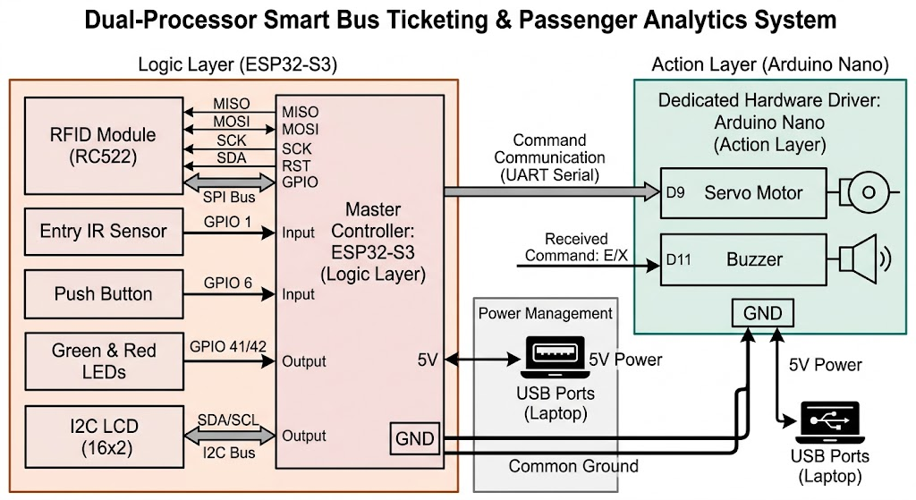

Execution Steps

- Connect RFID (SPI pins), LCD (I2C pins), Entry Button (GPIO 6), and Entry IR Sensor (GPIO 1).
- Connect Servo (D9) and Buzzer (D11).
- Connect ESP32 TX (Pin 43) to Nano RX (D0) and link both GND pins together.
- Plug both boards into your laptop via USB.
- Passenger scans RFID. ESP32 validates the ID and turns on the Green LED.
- Passenger presses the Push Button.
- ESP32 sends an 'E' command to the Nano via the serial wire.
- Nano beeps the Buzzer and opens the Servo Gate (90°).
- Passenger walks through the IR Sensor; ESP32 detects the beam break and adds +1 to the LCD count.
- After 3 seconds, the Nano closes the gate (0°) for the next passenger.

Uniqueness

Unlike standard ticketing machines, our solution combines occupancy monitoring with automated physical access control. By using a secondary Arduino Nano to offload the servo motor's timing requirements, we ensure the ESP32-S3 maintains high-speed processing for RFID data and sensor interrupts. The integration of "random balance" simulation allows for robust testing of edge cases in payment processing, making it a highly adaptable prototype for real-world transit applications.

Results and Discussion

Outcome & Results

The prototype successfully achieved a fully automated loop. The IR sensors accurately reflected the live count on the LCD without lag. The RFID system correctly identified unique tags, calculated the remaining balance after a fixed deduction, and triggered the entry gate only upon successful verification. The dual-controller setup proved stable, preventing system crashes during simultaneous sensor triggers and motor movements.

4. Results and Discussion

4.1 Project Image

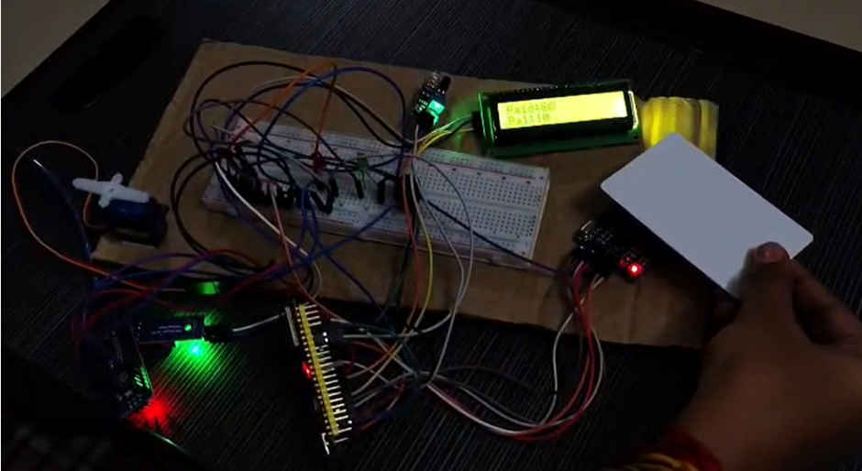

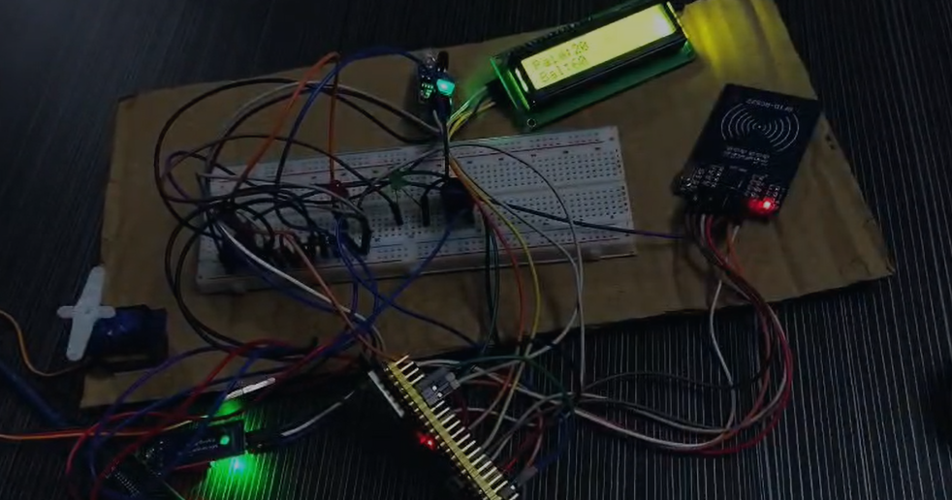

Demo Video:

https://www.flexclip.com/share/15644940vW52rNr5sGZFZCtyFBfrbCDzJJMIvPnb.html

https://drive.google.com/file/d/19UKikEi4sBNvTzVZX56fY_Jlpr3RjmZS/view?usp=drivesdk

